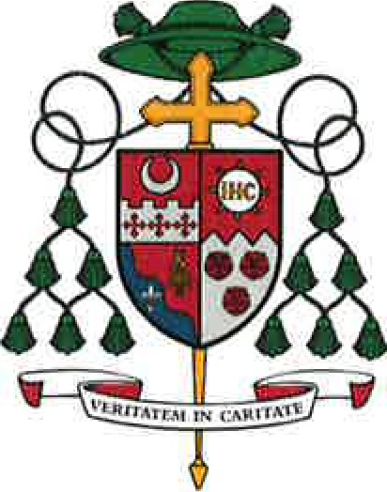
DIOCESE OF FORT WAYNE - SOUTH BEND
915 South Clinton Street • Post Office Box 390 Fort Wayne, Indiana 46801

November 22, 2022

Dear Brother Bishops,

I am writing to introduce a women’s apostolate that has grown out of the Diocese of Fort Wayne-South Bend and seeks to expand to other dioceses during the Eucharistic Revival. It is called “Kingdom Builders” and is currently active in eight parishes in my diocese and in three parishes in other dioceses.

“Kingdom Builders” promotes the spiritual growth of women through monthly gatherings, led by host parish core teams, focused on receiving the Father’s love through Scripture and Eucharistic Adoration, enkindling a living relationship with the Lord Jesus. Women are inspired to embrace the call to missionary discipleship. Here in the Diocese of Fort Wayne-South Bend, we have seen many good fruits from this apostolate, including fallen-away Catholics returning to the practice of the faith, women lukewarm in the faith becoming energized in their faith, marriages strengthened, and increased engagement in their parishes.

I can confidently recommend “Kingdom Builders” as a spiritually and doctrinally sound initiative, especially during the upcoming Parish Year of the Eucharistic Revival. More information can be found on their website buildingthroughhim.com. The website includes information on becoming a host parish for “Kingdom Builders” and for sending a “Pastor’s Guide” to pastors who may be interested in hosting this apostolate.

Fraternally yours in Christ,

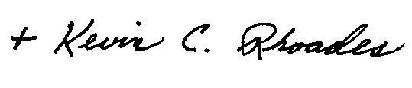

Most Reverend Kevin C. Rhoades
Bishop of Fort Wayne-South Bend

Telephone: 260-422-4611 • Fax: 260-969-9145 • www.diocesefwsb.org

